**Experiment 7: Laplace Transforms**

This experiment is intended to make the student to use MATLAB for experiments, relating to the Laplace Transform of continuous time signals. It is expected that the student will write a “readable” code in a file and execute.

In this experiment, we will find the Laplace Transform of given signals and Inverse Laplace Transform and verify the property that convolution of two time domain signals is equivalent to the multiplication of their Laplace Transforms

**NOTE:**

In order to perform Laplace Transform in Matlab “**symbolic**” mathematics need to be used, so students are expected to explore that functionality of matlab using **HELP**

**Run # 01 :** **Forward Laplace Transform**

1. Write Matlab program to find Laplace Transform of the following standard causal signals

**NOTE** : verify the result with your hand calculations

1. t

b) e–at

c) cos ωt

d) e–at sin ωt

e) t2 -3t

1. Explore the use of matlab buit-in function “simplify” and apply this function to simplify the above expressions

Ans:

Code:

syms t a w s tau neu;

%generate laplace tranforms

f = t; %Enter your t domain expression

F = laplace(f);

disp(simplify(F));

Outputs:

1. 1/s^2
2. 1/(a + s)
3. s/(s^2 + w^2)
4. w/((a + s)^2 + w^2)
5. -(3*s - 2)/s^3

**Run # 02 : Inverse Laplace Transform**

1. Write Matlab program to find Inverse Laplace Transform of the following S- domain signals

**NOTE :** verify the result with your hand calculations



$\frac{2}{s(s+1){(s+2)}^{2}}$

$\frac{1}{(s^{2}+s+1)(s+2)}$

$\frac{2}{s(s+1)(s+2)}$

(ii) After obtaining time expressions for the problem no.2, write matlab programs and plot all

those signals in time scale

Ans:

(i)

Code:

syms t a w s tau neu;

% generate inv laplace tranforms

G = 2/(s*(s+1)*(s+2)^2); %Enter your s domain expression

g = ilaplace(G);

disp(simplify(g));

Outputs:

1. (3*exp(-2*t))/2 - 2*exp(-t) + t*exp(-2*t) + 1/2
2. exp(-2*t)/3 - (exp(-t/2)*(cos((3^(1/2)*t)/2) - 3^(1/2)*sin((3^(1/2)*t)/2)))/3
3. exp(-2*t)*(exp(t) - 1)^2

(ii)

a)

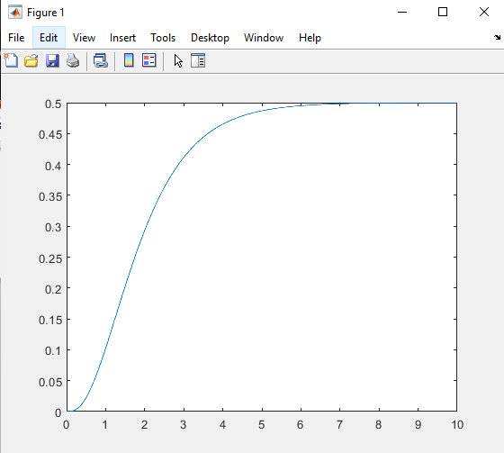

**b)**

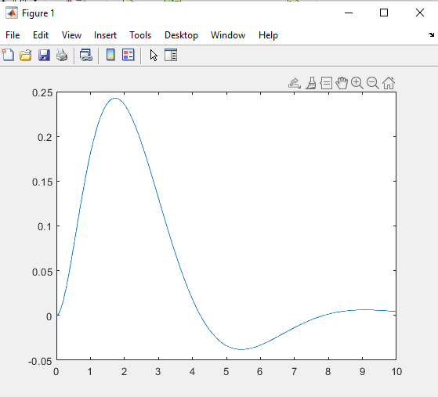

**c)**

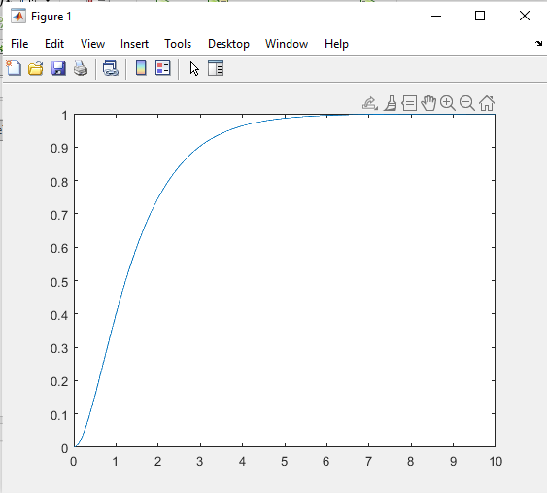

**Run # 03 : Verifying the property that convolution of two time domain signals is equivalent to the multiplication of their Laplace Transforms. → x1 (t) * x2 (t) = X1 (S) × X2 (S)**

Write MATLAB Program to verify the above property on the given signals





(b)

Ans:

a)

syms t a w s tau neu;

%generate laplace tranforms

x1 = t^2 - 2*t; %Enter your t domain expression

X1 = simplify(laplace(x1));

disp(simplify(X1));

x2 = t;

X2 = laplace(x2);

disp(simplify(X2));

% convolved_x = conv(x1, x2);

Y = X1*X2;

y = ilaplace(Y);

disp(simplify(y));

***And in another editer window:***

t = 0:0.01:5;

x1 = t.^2 - 2*t;

x2 = t;

convolved_x = conv(x1, x2);

clf

subplot(211);

plot(convolved_x);

T = 0:0.01:5;

y = (T.^3.*(T - 4))/12;

subplot(212);

plot(T, y);

Output:

If you look at the initial part of both the curves, it is the same. And if we allow the second curve to go for longer time then it will follow the shape of the first curve, but since it is too large it could not be plotted.

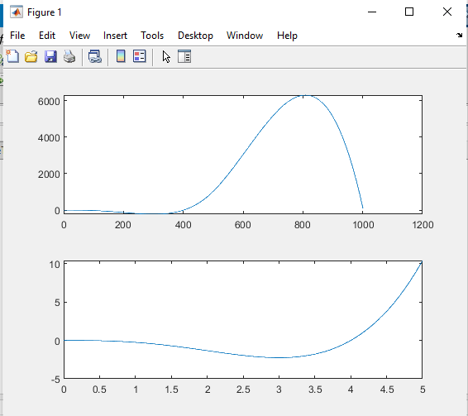

b)

Code:

syms t a w s;

%generate laplace tranforms

%Enter your s domain expression

X1 = 1/s - exp(-s)/s;

disp(simplify(X1));

X2 = exp(-s)/s - exp(-2*s)/s;

disp(simplify(X2));

Y = X1*X2;

y = ilaplace(Y);

disp(simplify(y));

***And in another editer window:***

t = 0:0.01:5;

x1 = 1.*(t>=0) - 1.*(t>=1);

x2 = 1.*(t>=1) - 1.*(t>=2);

convolved_x = conv(x1, x2);

clf

subplot(211);

plot(convolved_x);

T = 0:0.1:5;

y = heaviside(T - 1).*(T - 1) - 2*heaviside(T - 2).*(T - 2) + heaviside(T - 3).*(T - 3);

subplot(212);

plot(T, y);

Output:

The shapes are matching for the convolved signal and the Laplace transformed and the plotted signal

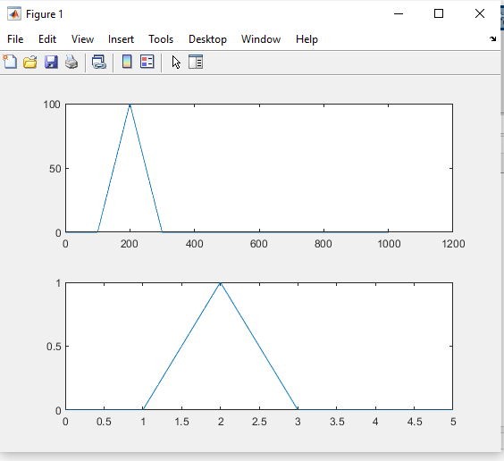

Tuesday Batch google form link <https://forms.gle/gR97DQk6oT8fdm4H7>

Deadline tentatively April 4th 5 PM

Thursday Batch google form link <https://forms.gle/o6BumQDcnGG4HwT66>

Deadline March 21st 5 PM

**Additional Problems**

1. Using Matlab find Laplace Transform of the following Causal Signals
2. tn e-at
3. tn-1 e-at/(n-1) !
4. 3 sin 2t + 3 cos 2t
5. 1+0.4e-2t sin3t